**Restaurant management system**

**Ahmed Diab**

**Restaurant Management system**

**Task 1: Identifying stakeholders – Create a list of stakeholders (as taught in Business Analysis Planning and Monitoring Knowledge Area)**

**STAKEHOLDERS**

**Internal Stakeholder:**

* **Waiter**
* **Business Analyst**
* **Subject matter expert**
* **Inventory manager**
* **Chef**
* **Delivery Boy**
* **Operational support**
* **Project Manager**
* **Tester**

**External Stakeholders**

* **CEO**
* **Management**
* **Customer**
* **Restaurant manager**
* **Sponsor**
* **Supplier**

|  |  |
| --- | --- |
| **ACTOR** | **What he can do on the System created** |
| CEO | * Track the day-to-day management of the system using a system not manual paper based * Request a feedback paper form to filled by the customer and added manually by the manager in the system. |
| Manager | * Able to search items in the menu using the search facility * Only he Can create and edit menu. Add delete items in the menu * Should have access to the sw * Only Managers Can do reservation for tables * Managers can add the customer feedback papers manually in the system |
| Waiter | * Able to search items in the menu using the search facility * Should have access to the SW * He can use this system for generating the bill table wise. * Not able to edit menu. * Only generate bills * Can check whether tables are reserved or not |
| Management | Management wants certain reports at the end of the day.   * Total sales of the day by dine in customers * Total sales of the day by home delivery customers * Total sales of the day (home delivery and dine in customers consolidated) * Name the top 10 most sold dishes for the day * Total sales every weekend (to be done by inputting the dates) * Total sales every month (to be done by inputting the dates) * List of dishes not sold in the current month (this is to phase out dishes that customers are not ordering) * Total sales across all cities * Total sales for each city |
| Business Analyst | * Elicit requirements from all stakeholders |
| Sponsor | * Authorize and approve the need, scope and budget for initiative |
| Project manager | * Facilitates and manage all the activities required to deliver the solution * He is accountable for the successful delivery of the project * Resource, task, cost and progress estimation Easy to calculate fines |
| Tester | * Verifies the requirements and functionality before the initial release. |
| Implementation SME | * Build the application (Restaurant management system) using Java |
| Customers | * They can review the digital menu * Can reserve the table online * Can pay cash or card * They can write a feedback |

**RACI matrix:**

|  |  |  |  |  |
| --- | --- | --- | --- | --- |
| **Stakeholders** | **Responsible** | **Accountable** | **Consulted** | **Informed** |
| Customer |  |  |  | I |
| Manager | R |  |  |  |
| Delivery Boy | R |  |  |  |
| Management |  |  | C |  |
| CEO |  |  | C |  |
| Implementation SME | R |  |  |  |
| Operation Support |  |  | C |  |
| Project Manager |  | A |  |  |
| Tester | R |  |  |  |
| Business Analyst | R |  |  |  |
| Sponsor |  |  |  | I |
| Waiter | R |  |  |  |

**Task 2:Create As-Is and Future Process map (using flowcharts). You can use any of the popular tools in the market like Microsoft Visio, Lucidchart, Creately, Pidoco, or Balsamiq**

**As IS process:**

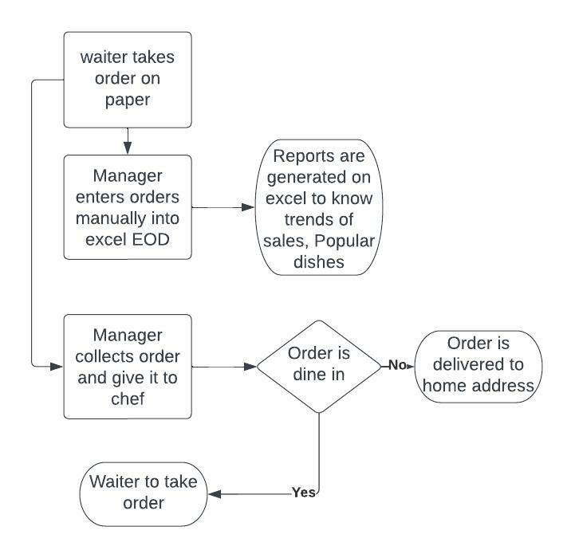

**Future status**

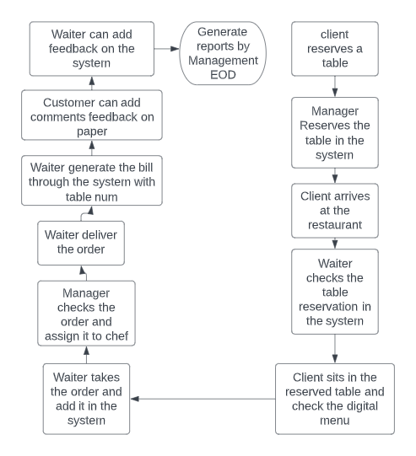

**For delivery orders:**

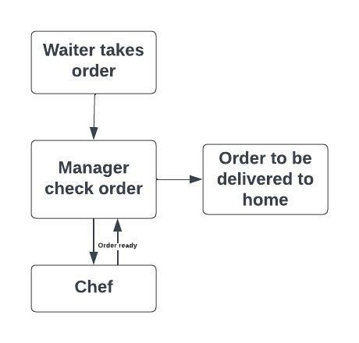

**Task 3: As a Business Analyst working on this project, find out the scope of the Restaurant Management Software. Write down the main features that need to be developed.**

**The scope of the Web based restaurant management to do the following:**

**1- Managers can Reserve the tables by the system**

**2- Waiters can check the tables’ reservation by the system**

**3- Automated process for ordering, viewing, billing and reporting**

**4- Users can search in the menus**

**5- Users can add feedback and store it in the system**

**6- Management can create reports EOD of sales trends and trending dishes**

**7- Can edit menu by manager and update**

**8- Generate bills**

**9- Customer can pay through payment gateway**

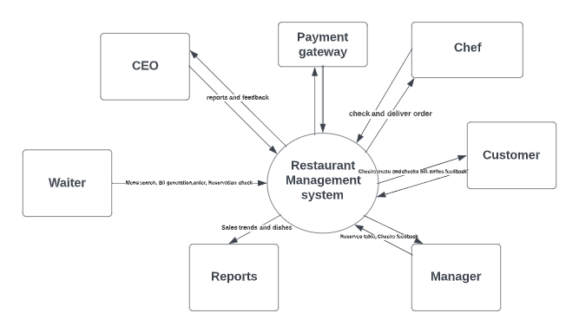

**Main features and authorization:**

|  |  |  |
| --- | --- | --- |
| **User Roles** | **Features** | **Authorization** |
| **CEO and Management** | Reports | View |
| **Waiter** | Menu List | View |
| Bill generation | View, Add |
| Feedback Form | View |
| Order Meal | View, Edit |
| Order Status | View |
| Table reservation | View |
| **Manager** | Menu List | View, Add, Edit |
| Feedback Form | View, Add |
| Order Meal | View |
| Order Status | View, Edit |
| Request Delivery | Edit |
| Table reservation | View, Edit |
| Request Delivery | Edit |
| **Chef and Prep Team** | Order Status | View |
| **Customer** | Menu List | View |
| Bill | View |

**Task 4: Write the in-scope and out-of-scope items for this software**

**In scope:**

* Reserve table
* View Menu
* Order meal
* Edit order
* View order
* Payment gateway
* Create/Edit Menu
* Generate bill
* Customer Feedback
* Reports
* Login permission
* Order delivery to customer

**Out of scope:**

* Supplier
* Prepaid payment
* Customer feedback on tablet instead of paper

**Task 5: Write out the business requirements, both functional and nonfunctional requirements.**

**Business requirements:**

The grill house CEO wants to replace the current system to a new restaurant system to track the day-to-day management of the restaurant.

The current system in the restaurant is paper based system which has many issues. Waiters take the bills on paper and paper-bill is presented to the customer. These bills and details are added EOD in Excel format which this excel is used to give the trends and details like daily, weekly and monthly sales and Trending dishes.

Management decided to switch to an automated process using new system instead of the manual current process to improve monitoring, efficiency, track sales and day-to-day management

The targeted system is an automated restaurant management system to efficiently use resources to increase productivity and sales.

This system will generate reports that can let the management check sales trends, popular dishes and other analysis reports which will enhance business decisions.

In addition, this system will be able to capture customer feedback.

**Functional requirements:**

* Manager can reserve tables
* Waiter can check the tables reservation, check seating
* Manager can create and edit menus
* Manager and waiter can search for a certain dishes in the menu
* Waiter can review menus
* Waiter can place order
* Waiter can generate bills
* Waiter can add customer feedback form in the system
* Waiter can process payment
* Waiter can edit the selection of the dishes of the menu during placing an order. He can add more items before generating the bill
* Waiter cannot edit or cancel the order once order is confirmed and submitted
* Manager can view and edit the submitted order
* Manager can give the order to chefs for cooking
* Once chef finished the order, waiter can deliver it to customer table
* Once chef finished the order for deliver. Delivery boy can deliver product to the customer home
* Once the waiter generated the bill to the customer. This bill should have waiter ID and table number
* Home delivery generated bill shall have the customer name, delivery ID and customer address
* Manager can add the customer feedback form information into the system

**Management wants to have the following reports from the system:**

* Total sales of the day by dine in customers
* Total sales of the day by home delivery customers
* Total sales of the day (home delivery and dine in customers consolidated)
* Name the top 10 most sold dishes for the day
* Total sales every weekend (to be done by inputting the dates)
* Total sales every month (to be done by inputting the dates)
* List of dishes not sold in the current month (this is to phase out dishes that customers are not ordering)
* Total sales across all cities
* Total sales for each city

**Non Functional requirements:**

**System Requirement:**

* Data should be stored in cloud
* Reliability, highly secure and scalable
* Restaurant management system can be used on any Windows and MacOS run computers
* Management system should also run in Apple IOS or android devices

**Usability:**

* Users will need active internet connection
* System should be, easy to understand, self-explanatory and very user friendly.

**Environments**

* Creating and maintaining the program in Java. As it will be very little in maintenance

**Task 6: Draw wireframes or mock screens for two of the features namely menu creation and table reservation. Use the technique prototyping or wireframing that is taught in the training. You can use any of the wireframing tools like Microsoft PowerPoint, Microsoft Word, Balsamiq, Sketch, Adobe XD, Adobe ILLustrator, Figma, UXPin, InVision Studio, Invision Freehand, or Moqups.**

**Wireframes:**

